
Lesson 9: On the Scoreboard
Scratch
VIDEO GAME CREATION
This week: track a real score, and show it - along with your lives - on screen, all the time, not just at the end.
Open your own [YourName]Game project from Lesson 8 - don't start a new one.
Tip: no new assets this week - this is a logic and UI lesson.

Setup
- Open your [YourName]Game project from Lesson 8.
- Create a new variable score (for all sprites, not "for this sprite only").

Level 1 - Minimal (MVP)
Destroying an enemy adds 10 points to your score. Score and lives are both visible on screen, all the time, not just at the start or end of the game.
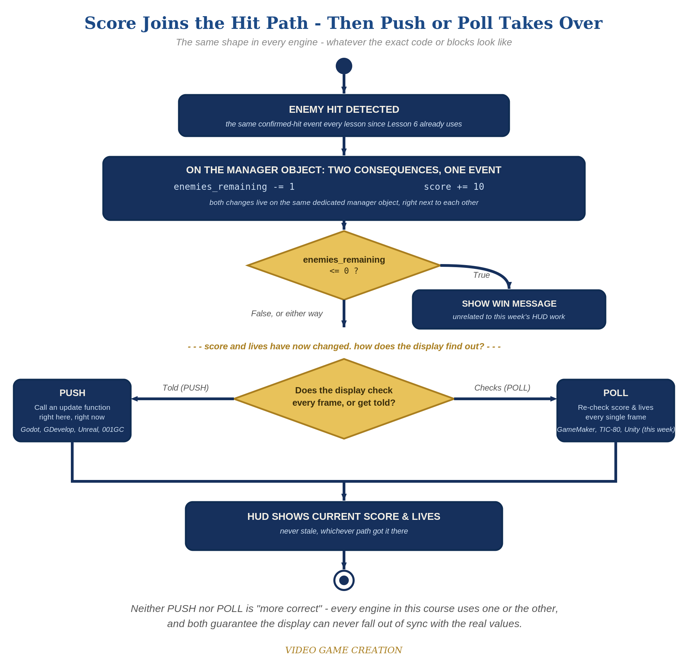
Score joins the hit path, then Push or Poll takes over - the same shape in every engine, whatever the exact code or blocks look like.
- On GameManager's existing "when I receive [enemy hit]" script - the same script that already decrements enemies_remaining - add "change score by 10". The Enemy sprite itself doesn't change: it still only ever broadcasts enemy hit and never touches score directly, the same report-only role it's had since Lesson 6.
- In the Variables palette, check the checkbox next to score AND the checkbox next to lives so both display automatically on stage - Scratch's simplest built-in way to show a live number, no coding required.
- Click the stage, shoot a few enemies, and let one escape - watch score go up and lives go down, both immediately, right on stage.
Highlighted lines are new this week; everything else is code you already have.
// GameManager (hidden sprite) - existing script:
when I receive [enemy hit]
change enemies_remaining by -1
change score by 10
if enemies_remaining = 0 then
broadcast [you win]
// Enemy sprite: no changes - it still only broadcasts [enemy hit] and never touches score.
// Variables palette: tick the checkbox beside score AND beside lives so both show on stage.

Level 2 - Complete (Alpha/Beta)
The score and lives readouts never show a stale or wrong number - they always match reality, immediately.
- Shoot 3 enemies and confirm score reads exactly 30 - not 20, not 40.
- Let an enemy escape and confirm score does NOT change - only lives should move.
- The on-screen numbers can never be "stale" here, since Scratch's variable watchers always show the live value automatically - there's nothing extra to keep in sync.

Level 3 - Refined (Ready to Publish) - pick any that interest you
- Visual: right-click the score or lives watcher on stage and choose "large readout" for a bigger, more game-like display; try dragging both watchers to a corner that doesn't overlap your sprites.
- Visual: change points-per-kill to something more interesting, like a random value between 5 and 15 (using "pick random"), for a bit of scoring variety.
- Structure: keep the score change inside the same "when I receive [enemy hit]" script as the enemies_remaining change, on GameManager - both are direct consequences of the exact same confirmed-hit event, so they belong together, on the one object that already owns all of this game's shared state.

If Something's Wrong
- Score doesn't appear on stage at all: confirm the checkbox next to the score variable (in the Variables palette) is actually checked.
- Score changes when an enemy escapes: the "change score by 10" block was added to GameManager's wrong script - move it into "when I receive [enemy hit]", not "when I receive [enemy escaped]".
- Score jumps by more than 10 per kill: check for a duplicate "change score by 10" block on GameManager, possibly left over from testing.

Want More?
Student Resource List > Scratch section, or scratch.mit.edu/ideas

